Protective effectiveness of SARS-CoV-2 infection risk among hybrid, vaccine, and infection-induced immunity against the omicron variant, K-SEROSMART

Authors: Yifan Zhang¹, Won Chang^{2, 3}, Kevin Dieckhaus⁴, Suyoung Jo⁵, Jina Han⁶, Hye Jin Baek⁶, Eunbi Noh⁷, Kyuhyun Yoon⁵, Jung Ae Kim⁸, Jaehun Jung⁹, Kyong Ran Peck¹⁰, Hye-Sook Jeong¹¹, June-Woo Lee¹¹, Ah-Ra, Kim¹¹, Hyeon Nam Do¹¹, Youngji Jo¹²*, Dong-Hyun Kim^{13,14}*

Affiliations
- Department of Statistics, University of Connecticut, CT, USA
- Department of Statistics, Seoul National University, Seoul, Korea
- Institute for Data Innovation in Science, Seoul National University, Seoul, Korea
- Departments of Medicine, School of Medicine, UConn Health, CT, USA
- Institute of Health and Environment, Seoul National University, Seoul, Korea
- Department of Preventive Medicine and Public Health, Ajou University School of Medicine, Suwon, Korea
- National Radiation Emergency Medical Center, Korea Institute of Radiological and Medical Sciences, Seoul, Korea
- College of Nursing, Kyungbok University, Namyangju-si, Korea
- Department of Preventive Medicine, School of Medicine, Korea University, Seoul, Korea
- Division of Infectious Diseases, Samsung Medical Center, Sungkyunkwan University School of Medicine, Seoul, Korea
- Division of Clinical Research for Vaccine, Center for Vaccine Research, National Institute of Infectious Diseases, National Institute of Health, CheongJu, Korea
- Departments of Public Health Sciences, School of Medicine, UConn Health
- Department of Social and Preventive Medicine, Hallym University College of Medicine, Chuncheon, Korea
- Institute of Social Medicine, Hallym University College of Medicine, Chuncheon, Korea

Corresponding Authors:
Dong-Hyun Kim: dhkims@hallym.ac.kr
Youngji Jo jo@uchc.edu

ORCID ID
Yifan Zhang, Department of Statistics, University of Connecticut, CT, USA <zfranky6@uconn.edu> ORCID ID

Won Chang, Department of Statistics, Seoul National University, Seoul, Korea; Institute for Data Innovation in Science, Seoul National University, Seoul, Korea <wonchang@snu.ac.kr> ORCID ID

Kevin Dieckhaus, Departments of Medicine, School of Medicine, UConn Health, CT, USA, ORCID ID

Suyoung Jo, Institute of Health and Environment, Seoul National University, Seoul, Korea, <josuyoung1@gmail.com> https://orcid.org/0000-0001-7790-0160

Jina Han: Department of Preventive Medicine and Public Health, Ajou University School of Medicine, Suwon, Korea / <gkswlsdk1984@hanmail.net> / https://orcid.org/0000-0002-4649-0012

Hye Jin Baek: Department of Preventive Medicine and Public Health, Ajou University School of Medicine, Suwon, Korea / <hyejin2126@naver.com> / https://orcid.org/0000-0001-8900-5542

Eunbi Noh: National Radiation Emergency Medical Center, Korea Institute of Radiological and Medical Sciences, Seoul, Korea / <enbi104@gmail.com> / https://orcid. org/0000-0002-9867-127X

Kyuhyun Yoon: Institute of Health and Environment, Seoul National University, Seoul, Korea / <swnknh@snu.ac.kr> / https://orcid.org/0000 0001-7017-1145

Jung Ae Kim: College of Nursing, Kyungbok University, Namyangju-si, Korea / <ds2qzt@gmail.com> / https://orcid.org/0000-0002-7715 5372

Jaehun Jung, Department of Preventive Medicine, Korea University College of Medicine, Seoul, Korea <eastside1st@gmail.com> ORCID ID

Kyong Ran Peck, Division of Infectious Diseases, Samsung Medical Center, Sungkyunkwan University School of Medicine, Seoul, Korea, <krpeck@skku.edu> 0000-0002-7464-9780

Hye-Sook Jeong, Division of Clinical Research for Vaccine, Center for Vaccine Research, National Institute of Infectious Diseases, National Institute of Health, CheongJu, Korea; https://orcid.org/0000 0009-0006-
9819-2398 <jeongnih@korea.kr>

June-Woo Lee, Division of Clinical Research for Vaccine, Center for Vaccine Research, National Institute of Infectious Diseases, National Institute of Health, CheongJu, Korea; https://orcid.org/0000-0002-
2923-5597 <junewoo1213@korea.kr>

Ah-Ra, Kim, Division of Clinical Research for Vaccine, Center for Vaccine Research, National Institute of Infectious Diseases, National Institute of Health, CheongJu, Korea; https://orcid.org/0000-0001-5610-3787 <kara9251@korea.kr>

Hyeon Nam Do, Division of Clinical Research for Vaccine, Center for Vaccine Research, National Institute of Infectious Diseases, National Institute of Health, CheongJu, Korea; https://orcid.org/0000-0002-9337-8859 <hndo@korea.kr>

Youngji Jo*, Departments of Public Health Sciences, School of Medicine, UConn Health <jo@uchc.edu> http://orcid.org/0000-0002-1440-2786

Dong-Hyun Kim*Department of Social and Preventive Medicine, Hallym University College of Medicine, Chuncheon, Korea <dhkims@hallym.ac.kr> https://orcid.org/0000-0002-1492-5253

Abstract (250 words)

Background: Evaluating infection risk after the Omicron wave is challenging due to unconfirmed infections. We compared survival probabilities and hazard ratios for SARS-CoV-2 breakthrough infections across hybrid (infection + vaccination), vaccine-only, and infection-only immunity groups in South Korea, incorporating both laboratory-confirmed and serology-inferred infections.
Methods: Using nationwide surveillance data, we classified individuals as hybrid, vaccine-only, and infection-only based on spike (S) and nucleocapsid (N) antibody profiles and vaccination history. Infections were classified by laboratory-confirmed cases or N titer levels between August and December 2022. We analyzed a conservative outcome (confirmed cases only) and an inclusive outcome (confirmed + inferred). Kaplan–Meier and time-varying Cox models estimated risks and hazard ratios.
Results: By month 4, the conservative outcome risks were 2% (95% CI: 1.3–1.9) for hybrid, 4% (2.3–5.6) for infection-only, and 30% (17.3–41.8) for vaccine-only. Inclusive outcome risks increased to 20% (18.1–19.9), 24% (19.6–29.1), and 40% (36.3–43.5), respectively. Hybrid immunity’s advantage waned: the log hazard ratio for vaccine-only vs. hybrid dropped from 3.44 to 0.13; for infection-only vs. hybrid, from 3.31 to –0.56. Unconfirmed infections comprised 92% of hybrid, 81% of infection-only, and 50% of vaccine-only cases, primarily in adults aged 40–59 (37% hybrid, 45% vaccine-only) and youth <20 (69% infection-only).
Conclusions: Inclusive outcomes using anti-N titers reveal hybrid immunity’s stronger but rapidly waning protection, nearing vaccine-only risk and falling below infection-only by month 4. High unconfirmed infection rates in middle-aged adults (hybrid/vaccine) and youth (infection-only) underscore the need for enhanced serological surveillance and timely boosters in Omicron-driven epidemics.
Introduction

Both natural SARS-CoV-2 infection and COVID-19 vaccination play crucial roles in developing population-level immunity [1]. While immune responses are complex and multifaceted, epidemiological studies often rely on measurable indicators like antibodies to assess population immunity and the durability of antibody responses following infection and/or vaccination [2]. Several epidemiological studies show that hybrid immunity (a result of both infection and vaccination) had the highest magnitude and durability of protection against all outcomes, emphasizing the importance of providing vaccination to previously infected individuals as infection-induced protection against reinfection wanes rapidly, but vaccination further increases durability [3,4]. However, the extent and duration of hybrid immunity’s waning—especially following Omicron infections—remain largely uncharacterized. The widespread rise of the Omicron (B.1.1.529) variant, which has led to a significant number of individuals possessing hybrid immunity, complicates efforts to measure and compare this protection. Disparate rates and timings of past infections, variations in vaccine types and number of doses, and evolving variants of concern capable of evading existing immunity present additional challenges in estimating the overall magnitude and durability of this protection [5].

Recent systematic reviews and meta-analyses have provided more comprehensive evidence regarding the durability and efficacy of hybrid immunity during the Omicron period. A 2023 systematic review by Bobrovitz et al. analyzed data from over 65 studies and found that hybrid immunity conferred significantly stronger and more durable protection than vaccination or infection alone, with protection against severe disease remaining robust (>95%) at 12 months post-exposure while protection against reinfection declined more substantially to approximately 41.8%% during this timeframe [6]. A recent study found that hybrid immunity, especially with booster vaccination, provided the strongest protection against SARS-CoV-2 reinfection—reducing risk by up to 57% compared to natural immunity alone and by 65% compared to complete vaccination alone—with effectiveness highest shortly after boosting and gradually waning over time. [7,8]. However, much of the existing research on SARS-CoV-2 seroprevalence-based immunity has focused on specific groups—such as healthcare workers or immunocompromised individuals [9]), leaving the magnitude and durability of immune protection in the general population less thoroughly explored [10,11]. Moreover, most large-scale seroprevalence studies across various countries primarily account for laboratory-confirmed infections, overlooking a potentially sizable number of unreported or asymptomatic cases [12–14]. These findings highlight that while hybrid immunity provides the strongest protection against severe outcomes during the Omicron era, continuous surveillance remains essential as new immune-evasive variants emerge and population immunity profiles evolve.[15]

In August 2022, the nationwide Korea Seroprevalence Study of Monitoring of SARS-CoV-2 Antibody Retention and Transmission (K-SEROSMART) was launched to examine the extent of COVID-19 infections—including unrecognized cases—across local communities through longitudinal cohort surveillance [3]. The study revealed that most individuals had SARS-CoV-2 antibodies and uncovered a substantial number of previously undetected cases. With new Omicron sub lineages continually challenging existing vaccines, there remains a knowledge gap regarding how vaccination and infection influence long-term protection across diverse immunity groups respectively. This study aims to compare survival probabilities and hazard ratios for breakthrough infections across different immunity groups, incorporating both laboratory-confirmed and serology-inferred events, which can cause widespread silent transmission and impede targeted interventions. By shedding light on which populations are most susceptible to breakthrough infections and the relative risk and durability of hybrid, vaccine and infection-induced protection, these findings provide valuable evidence for tailoring targeted interventions and optimizing long-term immunization strategies in diverse community settings.

Methods

Participants. The fieldwork for K-SEROSMART Wave 1 was conducted between August 12 and September 5, 2022, with a total of 9,945 individuals from 5,041 households participating, across 258 communities, representing all basic local governments in South Korea. During face-to-face household interviews, participants self-reported health status, demographic and socioeconomic characteristics. Subsequently, participants visited a community health center or medical clinic for blood sampling. In December 2022, the subsequent second survey (Wave 2) was conducted involving serial sampling of the same population from K-SEROSMART Wave 1 to estimate the change in immunity, reinfection rates, and effectiveness of COVID-19 vaccinations, 4 months after the initial survey. The second survey's timing in December 2022 was chosen based on Korea's COVID-19 epidemiological context. Following the first survey in August 2022, during the Omicron BA.5-driven summer peak, December coincided with a minor winter resurgence led by BA.5 sub-lineages BF.7 and BQ.1, and the start of the national bivalent vaccination campaign. This timing was appropriate for evaluating short-term antibody titer changes and monitoring community reinfections [16]. A total of 8,826 individuals were contacted, of whom 7,528 completed K-SEROSMART Wave 2. More detailed descriptions of the cohort study design and data collection methods are published elsewhere [17]. All public health centers and medical institutions in Korea are required to report the results of rapid antigen tests and reverse transcription polymerase chain reaction (RT-PCR) screening tests for newly confirmed COVID-19 cases to the COVID-19 information management system of the KDCA within 24 hours. For participants in the survey, the names, sex, dates of birth, and home addresses of those who consented to the use of their personal information were used to link the survey data with their COVID-19 confirmation and vaccination history information provided by the KDCA [17].

Sample collection and cohort definitions. The serum samples were analyzed for SARS-CoV-2 antibodies using the Elecsys Anti-SARS-CoV-2 test (Roche). Blood samples were analyzed for the presence of antibodies to spike proteins (anti-S) and antibodies to nucleocapsid proteins (anti-N) SARS-CoV-2 proteins using an electrochemiluminescence immunoassay. The results of the anti-S assay were presented numerically and deemed positive for anti-S when the cut-off index was greater than or equal to 0.80 U/mL, signifying the formation of antibodies due to natural infection or vaccination [18]. The results of the anti-N assay were classified as reactive or non-reactive, with a specified cut-off index. A cut-off index of 1.0 or higher indicated an anti-N result of reactive, meaning that the patient tested positive for anti-N; this suggested that antibodies had previously formed due to natural infection [18].

In this analysis, we defined the cohort by the following four distinct immunity types: hybrid-induced immunity (S⁺N ⁺ with vaccination history) [19,20], vaccine-induced immunity (S⁺N⁻ with vaccination history), infection-only induced immunity (S⁻N ⁺, S⁺N⁻or S⁺N ⁺ with no history of vaccination), and naive (S⁻N⁻). (Figure 1) Notably, following the Omicron wave in South Korea, the majority of the population (88%) exhibited either hybrid or vaccine-induced immunity, with only 8% showing infection-induced immunity and 2% remaining without immunity as of August 2022. Figure 1 provides an overview of the cohort generation process for different immunity groups. The demographic and clinical characteristics of these groups are detailed in Table 1 and 2.

Figure 1: Cohort Classification and Outcome Determination Based on Vaccination and Infection Status, using data from K-SEROSMART Waves 1 and 2, and KDCA from August 2022 to December 2022

A. Inclusive outcome
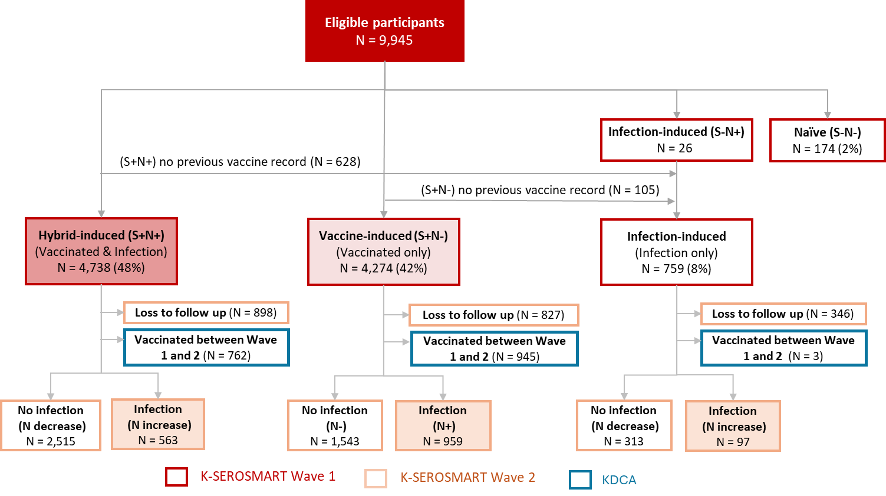
B. Conservative outcome
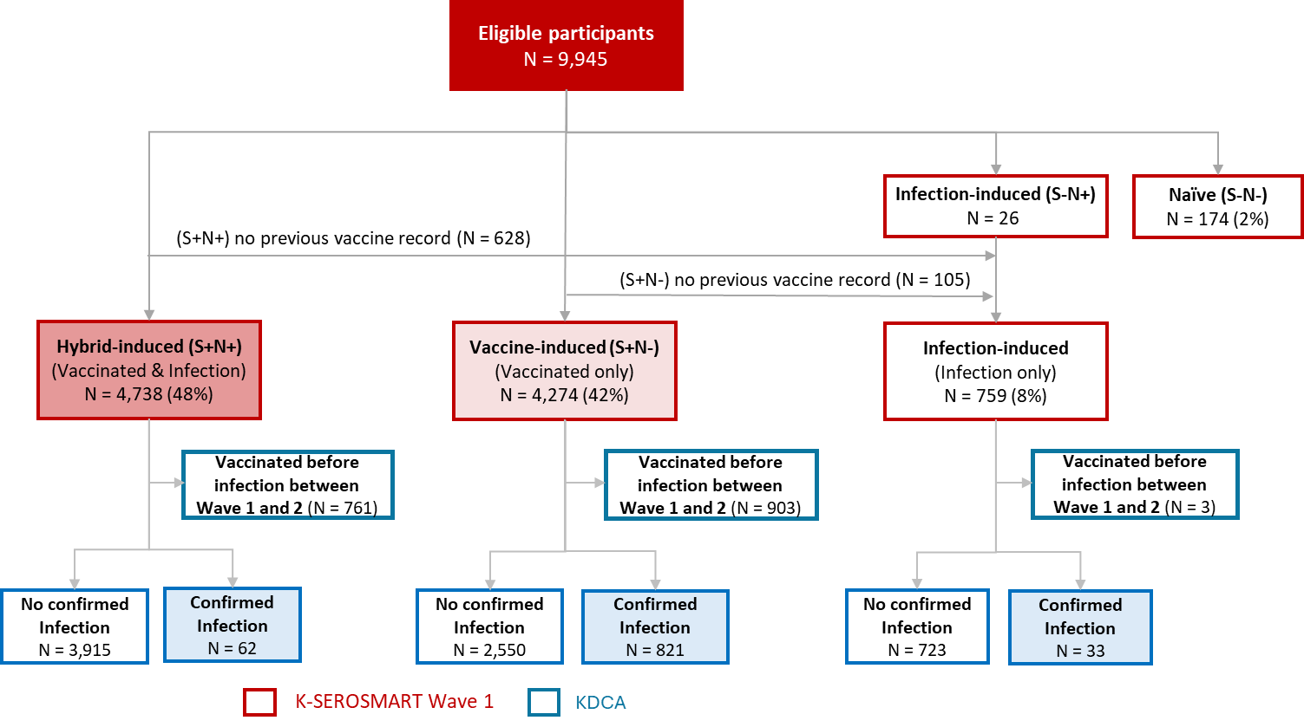

COVID-19 infection outcome definitions: We assessed two different outcome definitions: 1) conservative outcomes (confirmed infections); and 2) inclusive outcomes (confirmed and unconfirmed infections) that occurred between K-SEROSMART Waves 1 and 2. (Figure S1) Confirmed infections were identified through positive test results recorded in the KDCA database. Undiagnosed/unconfirmed infections -- without a corresponding COVID-19 diagnosis in KDCA records-- were defined as serologically identified infections based on anti-N status or titer level change between Wave 1 and Wave 2. In the vaccine group, undiagnosed infections were identified by a change in anti-N status from nonreactive at Wave 1 to reactive at Wave 2. In the hybrid and infection-only groups, undiagnosed infections were defined by a statistically significant increase in anti-N titer level between Waves 1 and 2—based on criteria of sensitivity >80% and specificity >90% (Figure S2). Because N-antibodies typically appear one to two weeks (sometimes longer) after infection onset, this approach balances the risk of misclassifying non-infected individuals against missing true infections. Unconfirmed infections in the hybrid and infection-only cohorts were classified when the follow-up-to-baseline anti-N ratio exceeded a threshold (N2/N1 > 1), a cut-off chosen to keep the false-positive rate below 10 %.

To ensure the validity of our assessment of the difference of infection risks by the immunity status measured at Wave 1, we implemented the following exclusion criteria: First, for the inclusive outcome definition, we excluded those who did not participate in Wave 2 (e.g. loss to follow up, N=898 for the hybrid induced group) because their change in anti-N status could not be assessed. We also excluded participants who received any vaccination during the interval between Waves 1 and 2, since we don't know the exact timing of unconfirmed infection. (e.g. N=762 for the hybrid induced group). This exclusion prevented distortion of the relationship between baseline (Wave 1) anti-S and anti-N status (which defined hybrid, vaccine, and infection-induced immunity groups) and subsequent infection risk, as vaccination would alter antibody profiles and obscure the baseline effect we aimed to measure. Second, for conservative outcome definition, based on the exact timing of vaccination and confirmed infection from the KDCA database, we included participants who received vaccination after their confirmed infection event dates (e.g. N=1 for the hybrid induced group) between Wave 1 and 2, as these post-infection vaccinations could not have influenced the already-occurred infection events. We also included those who did not participate in Wave 2 (loss to follow up) but have confirmed infection records from the KDCA database (e.g., N=15 for the hybrid induced group) between Waves 1 and 2.

Statistical analyses. We conducted survival analyses for both conservative and inclusive outcomes across the three immunity groups. Missing infection dates for unconfirmed cases were imputed using the {mice} R package with predictive mean matching (PMM) [21]. Prior to imputation, dates were transformed into time gaps from the first surveillance. A regression model—incorporating age, sex, vaccine doses, comorbidities, time since the last immunological event, and anti-S/anti-N levels—estimated gaps for confirmed cases. For each missing value, PMM selected a random gap from the k-nearest neighbors in the observed data, matched by predicted time gaps, preserving the variability and distribution of confirmed infections, avoiding the over-smoothing typical of mean or median imputation[22]. Survival probabilities for the hybrid, vaccine-induced, and infection-induced immunity groups were compared using Kaplan–Meier survival curves weighted by age-standardization according to the primary criterion (Figure 2).

To formally assess the association between immune status and the risk of infection during the first and second survey periods, we employed an age-standardized Cox proportional hazards model incorporating the same weighting scheme. However, the result of the Schoenfeld residual test indicated a violation of the proportional hazards assumption in both the conservative and inclusive cohorts (Table S1). The null hypothesis assumes constant hazard ratios over time, while the alternative permits time-varying effects. Rejection of the null hypothesis suggests that the relative infection risks among the hybrid-, vaccine-, and infection-induced immunity groups vary over time, undermining the validity of standard Cox estimates and necessitating time-varying modeling approaches. Therefore, we applied a Cox proportional hazards model with time-varying coefficients using log-transformed time interactions (Table S2). Specifically, vaccine-induced and infection-induced immunity were modeled as functions of log(time), allowing their effects to vary continuously over the follow-up period. This approach relaxes the proportional hazards assumption by incorporating covariate-by-time interactions, enabling hazard ratios to evolve over time while preserving interpretability on the hazard scale [23,24]. The use of log-transformed time is particularly effective in capturing gradual changes in covariate effects, which often reveal departures from proportionality on the log(time) scale [25]. Similar strategies have been used in prior studies to model time-varying effects of treatment or exposure in epidemiological and clinical settings [26,27], offering a flexible framework for evaluating non-proportional hazards in immunity-based survival outcomes. To adjust for potential confounders such as age, sex, and BMI, we initially fitted a full model including all covariates. Only age and sex were statistically significant, and backward stepwise selection based on AIC and BIC identified the model with age and sex alone as optimal. While AIC and BIC should be interpreted cautiously in time-varying Cox models with log-time interactions due to increased complexity, they remain useful for comparing nested models under the same structure. Additionally, time since the most recent immunological event could not be included, as a substantial proportion of individuals in the infection-induced immunity group lack documented dates of prior infection -- especially those who are classified by exclusion from the hybrid- and vaccine-induced groups. Consequently, it is not possible to accurately determine the time since the most recent immunological event for this group. Moreover, comorbidity burden was not significantly associated with infection risk and did not improve model performance in either cohort, and was therefore excluded from the final models.
The final model is specified as follows. Let $t$ denote time in months and let $h(t)$ represent the hazard function at time $t$. The baseline hazard function is denoted by $h_{0}(t)$. The covariates $Immune_{vac}$ and $Immnue_{infec}$ are binary indicators for vaccine-induced and infection-induced immunity, respectively, with hybrid-induced immunity serving as the reference category. Age and sex are similarly included as categorical indicator variables. The hazard function is expressed as:
$$h(t)=h_{0}\left(t\right)⋅exp⁡\{β_{1}⋅Immune_{vac}+ β_{2}⋅Immune_{infec}+β_{3}⋅Age_{<20}+β_{4}⋅Age_{20-39}+β_{5}⋅Age_{40-59}+β_{5}⋅Sex_{Female}+ γ_{1}⋅Immune_{vac}⋅\log\left(t\right)+ γ_{2}⋅Immune_{infec}⋅log⁡(t)\}$$

To validate the time-varying Cox model, we performed a heuristic landmark analysis by dividing follow-up into monthly intervals and estimating observed hazard ratios (Table S2, S3). This allowed comparison between model-based estimates and empirical patterns over time. Similar strategies have been used in previous studies to assess the adequacy of time-varying effects and support model validation through interval-specific estimates [28,29]. Within each interval, we assessed differences in infection risk across immunity groups using Fisher’s Exact Test, which is well-suited for binary outcomes and small event counts, particularly in later time periods.

Results.

Table 1: Descriptive Characteristics of the Study Population by Immunity Type (Hybrid-, Vaccine-, and Infection-induced), August 2022 to December 2022.
Note: The sum of the proportion of the infection-induced group in time since the most recent immunological event is not 100% because some individuals do not have the last confirmed infection records or vaccination records.

Table 1 shows significant demographic and clinical differences among hybrid-induced (S+N+), vaccine-induced (S+N–), and infection-induced immunity groups. The infection-only group was notably younger (68.2% aged <20 vs. 8.4% hybrid, 5.9% vaccine). Hybrid and infection-only groups had more recent immunological events (74% and 66% within 6 months, respectively, vs. 37% vaccine). The hybrid group was less likely to have received four vaccine doses before Wave 1 (13% vs. 25% vaccine). Across both outcome definitions, the hybrid group had the lowest infection rates: under the conservative definition, 2% vs. 4% (infection-only) and 21% (vaccine-only); under the inclusive definition, 12% vs. 14% and 24%, respectively.

Table 2: Characteristics of Participants of Breakthrough Infection Events by Immunity Type (Hybrid-, Vaccine-, and Infection-induced) and Outcome Definition (Conservative vs. Inclusive), August 2022 to December 2022
Note: confirmed infections and N increase cases are defined according to the conservative and inclusive cohorts outlined in Figure 1. The N increase but not confirmed cases group is a subset of the ‘N increase’ group, excluding individuals with confirmed infections. In the hybrid group, 563 participants showed an N-titer rise between Wave 1 and 2; Among these participants, 520 lacked laboratory‑confirmed infection dates, whereas 43 had dates recorded in the KDCA database—forming part of the 62 confirmed cases. The remaining 19 missed Wave 2 but were still counted in the conservative outcome because their infection dates were confirmed in the KDCA database.

The unconfirmed infection data reveals notable differences between conservative and inclusive outcomes across immunity groups. Under the inclusive criteria, the number of potential infections is substantially higher than in the conservative approach (e.g., 563 vs. 62 in the hybrid group; 959 vs. 821 in the vaccine group; 97 vs. 33 in the infection only group), because it includes “N increase/positive but not confirmed” cases. This pattern is further reflected in the confirmation status distribution: 92% (520 out of 563) of infections within the hybrid-induced group not receiving laboratory confirmation, and 81% (79 out of 97) in infection-only group, while 50% (477 out of 959) of infections in the vaccine-induced immunity group.

The discrepancy between conservative and inclusive outcomes is mainly driven by two factors: the interval since the most recent immunological event and the participants’ age distribution. At Wave 1, the inclusive definition classified 33 % of hybrid-immunity cases as < 1 month past their most recent immunological event, versus just 4 % under the conservative definition. Similarly, among vaccine-only cases, the inclusive definition captured 19 % that were < 1 month from the most recent immunological event, compared with 5 % under the conservative definition. Based on Anti-N threshold sensitivity analyses, our decision criteria for infection status may have approximately a 10% false-positive error. (Figure S2) This misclassification is most likely among unconfirmed individuals participating in Wave 1 within the first month after their latest immunological event with delayed N-titer rise (e.g. 10% out of 181 for hybrid and out of 24 for infection only). Age distribution also matters; adults aged 40–59 account for most unconfirmed infections in the hybrid (37 %) and vaccine-only (45 %) groups, whereas the infection-only group is dominated by those < 20 years (69 %).

Figure 2: Kaplan-Meier Survival Curves by Immunity Type (Hybrid-, Vaccine-, and Infection-induced) and Outcome Definition (Conservative vs. Inclusive), August 2022 to December 2022
- Conservative outcome definitions | - Inclusive outcome definitions
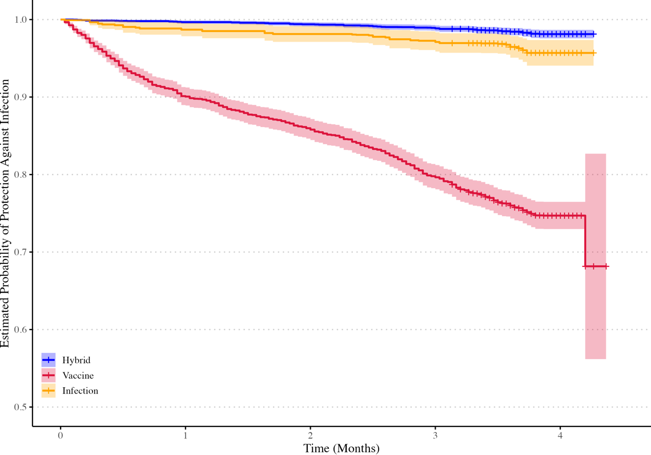 | 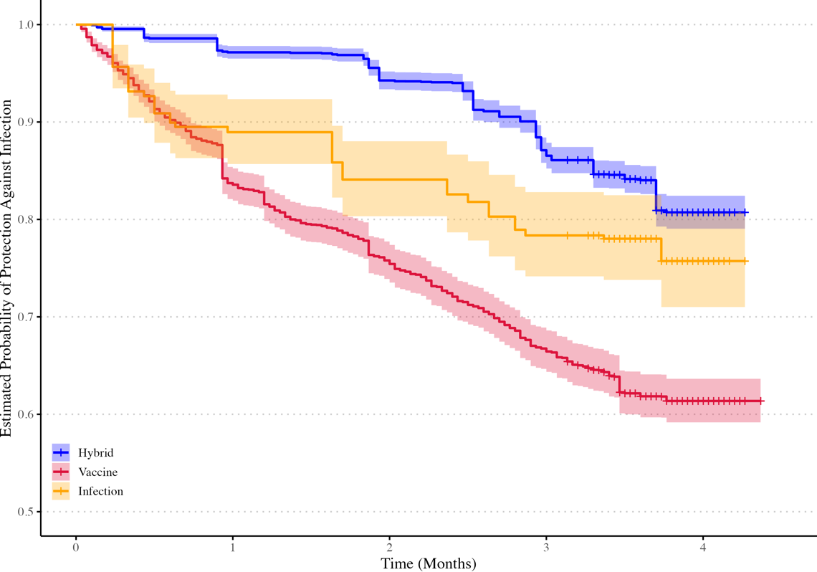

Figure 2 presents Kaplan-Meier survival curves depicting the likelihood of remaining COVID-19 infection-free over time, based on conservative (Panel A) and inclusive (Panel B) outcome definitions. The analysis compares hybrid, vaccine, and infection-induced immunity cohorts over a 4-month period between Waves 1 and 2. By month 4, the conservative outcome definition yielded infection risks of 2 % (95 % CI 1.3%–1.9%) for the hybrid-immunity, 4% (2.3%-5.6%) in the infection only, and 30 % (17.3%–41.8%) in the vaccine-only; under the inclusive outcome definition, these rose to 20 % (18.1%–19.9%), 24% (19.6%-29.1%) and 40 % (36.3%–43.5%) respectively.

Figure 3: Time-varying Cox Log Hazard Ratios for Vaccine and Infection Only-Immunity Groups Against Hybrid Immunity Group, August 2022 to December 2022
- Conservative outcome definition | - Inclusive outcome definition
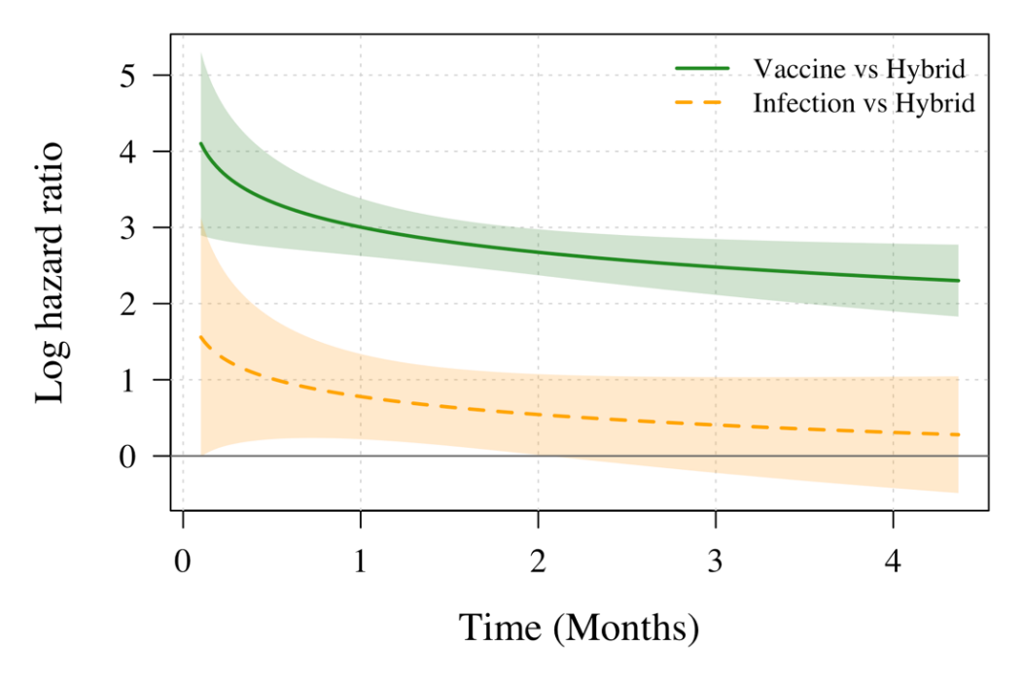 | 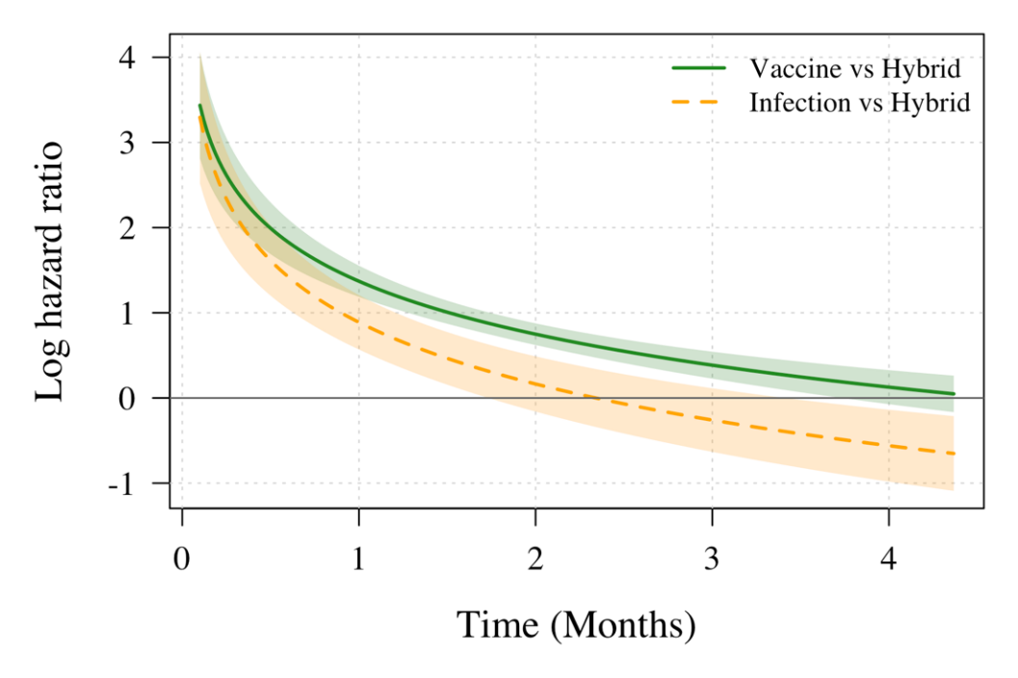
Table 3. Monthly Log Hazard Ratios Estimated from Time-varying Cox Regression for Vaccine and Infection Only-Immunity Groups Against Hybrid Immunity Group, August 2022 to December 2022
- Conservative outcome definition | - Inclusive outcome definition
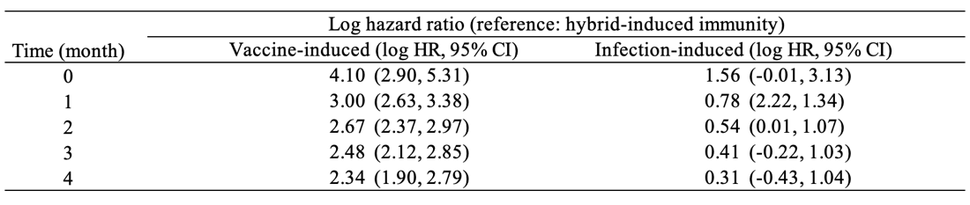 | 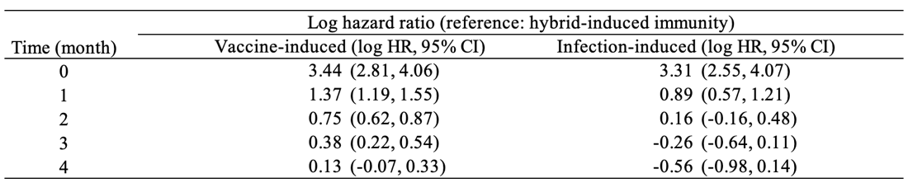

Figure 3 illustrates the time-varying log hazard ratios estimated from the time-varying Cox regression models, where vaccine-induced and infection-induced immunity are compared to hybrid-induced immunity with log-transformed time interactions. Comparing the two definitions—conservative (Panel a) and inclusive (Panel b)—reveals substantial differences in the estimated log hazard ratios for vaccine-induced immunity at baseline. Under the conservative outcome definition, hybrid immunity consistently exhibited the lowest log hazard ratios of laboratory-confirmed (predominantly symptomatic) COVID-19 over four months. Vaccine-only immunity showed the greatest excess risk: its log hazard ratios versus hybrid declined from 4.10 (95% CI: 2.90, 5.31) at baseline to 2.34 (1.90, 2.79) at month 4, yet remained statistically significant. Infection-only immunity began with a log hazard ratio of 1.56 (-0.01, 3.13), dropping to 0.78 at month 1 and 0.31 by month 4; confidence intervals overlapped the null from month 3 onward, indicating convergence with hybrid immunity.

From the inclusive outcome definition, at the time immediately following the first survey, the vaccine-induced group exhibited a high level of infection risks, with a log hazard ratios of 3.44 (2.81, 4.06) relative to the hybrid-induced group. This difference diminished over time, and by the fourth month, the log hazard ratios declined to 0.13 (–0.07, 0.33), suggesting that the relative protection offered by hybrid and vaccine-induced immunity had nearly equalized. Similarly, the infection-induced group began with an elevated log hazard ratios of 3.31 (2.55, 4.07), but under the inclusive outcome definition, its log hazard ratios dropped below zero after the second month, indicating a shift toward greater protection relative to hybrid immunity. By the fourth month, the entire confidence interval for the infection-induced group lay below zero as –0.56 (–0.98, –0.14), suggesting a statistically significant protective advantage. These temporal patterns are consistent with the month-specific hazard ratios in Table S3, where the hazard ratio comparing hybrid to vaccine-induced immunity declined from 5.64 to 1.33, and from 3.63 to 0.35 when comparing hybrid to infection-induced immunity. Together, these findings suggest that the relative advantage of hybrid-induced immunity diminishes rapidly and substantially over a four-month follow-up period.

Discussion

Using nationwide, community-based surveillance conducted after South Korea’s Omicron wave, we compared infection risks among hybrid, vaccine-only, and infection-only immunity. Hybrid immunity consistently exhibited the lowest log hazard ratios of both inclusive and conservative outcomes over a four-month period. Notably, including unconfirmed infections revealed a significant reduction in the protective benefit of hybrid immunity, with the infection risk rising from 2% to 20% in the hybrid group, and altering the comparative hazard ratios among immunity groups. The log hazard ratio of hybrid vs. vaccine-only immunity dropped from 3.44 to 0.13, and that of hybrid vs. infection-only immunity reversed from 3.31 to –0.56. Several factors may contribute to these trends, including differences in the time since the last immunological event and variations in cohort demographic profiles across the immunity groups. Our findings underscore the substantial impact of unconfirmed infections—comprising 92% of hybrid, 81% of infection-only, and 50% of vaccine-only cases—particularly among adults aged 40–59 and adolescents under 20. Under the conservative outcome definition, the log hazard ratio of hybrid vs. vaccine-only immunity dropped from 4.10 to 2.34, and that of hybrid vs. infection-only immunity dropped from 1.56 to 0.31. Since laboratory-confirmed cases primarily reflect symptomatic infections, this suggests that vaccination provides additional protection against severe infections, but this benefit wanes within a few months. Further research is needed to evaluate booster efficacy and define the optimal interval between the last immune event—vaccination or infection—and subsequent doses. Comparing different infection outcome definitions based on quantitative Anti-N titers reveals a more nuanced and rapidly evolving immunity landscape, with significant implications for both epidemiological analysis and clinical decision-making.

By incorporating unconfirmed infections through inclusive outcome definitions, we revealed previously hidden cases, enabling more comprehensive risk evaluation and more accurate immunity group comparisons. Altarawneh et al[30] also compared strict (e.g., symptomatic, PCR-confirmed) and inclusive (e.g., serologic evidence-based) outcome definitions, finding that inclusive definitions detected more infections in hybrid immunity groups, reducing their apparent protective advantage over infection-only groups. Studies from 2022–2023 consistently show Omicron sub-variants (e.g., BA.1, BA.2, BA.5) cause higher rates of breakthrough infections in hybrid immunity groups compared to pre-Omicron variants. These infections are often mild or asymptomatic and go unconfirmed, highlighting the importance of inclusive outcome definitions to fully capture infection risk. Our results also confirm earlier evidence of hybrid immunity’s superior—but rapidly waning—protection[6,23]. Chemaitelly et al [32], using continuous time-dependent models, showed hybrid immunity’s effectiveness against Omicron infection dropping from 70% at 1 month to 30% by 6 months, driven by Omicron’s immune evasion and the faster decline of vaccine-derived protection. Bobrovitz et al [6], applying a piecewise approach, identified a hazard ratio crossover (HR shifting from >1 to <1 by month 4) for hybrid vs. infection-only immunity, similar to our findings. These patterns highlights that immunity comparisons are dynamic, requiring careful consideration of temporal, immunological, and epidemiological factors to inform effective public health strategies[33].

At baseline, the time-varying hazard ratios reveal higher infection risks in the vaccine-only immunity group, likely due to their last immune-boosting event occurring ≥6 months prior, allowing significant antibody titer to decline against Omicron sub-variants. Conversely, the infection-only group, despite typically having <6-month immunological time gaps, also shows elevated initial risk, suggesting qualitative differences in protection beyond timing. Natural infection may induce a broader but less consistent immune response compared to vaccines, influenced by infecting strain, disease severity, and host factors, potentially resulting in weaker or narrower immunity in some individuals, increasing early reinfection risk [34,35]. Survival bias may emerge due to differential time gaps between immunity groups, as higher early hazards in the vaccine-only group disproportionately remove highly susceptible individuals, leaving a less susceptible "survivor" subset. This bias likely underestimates later risks in the vaccine-only group, who consist of more proportion of older population with a longer time since the last immunological event, loses its most vulnerable members early. This dynamic narrows the apparent risk gap with the hybrid immunity group, even if underlying protection is not truly superior, emphasizing the need for timely boosters and non-pharmaceutical precautions in this group. Our study employs a robust approach to quantify and compare infection risks across immunity groups by estimating infection timing (via PMM) for survival analysis and quantifying uncertainty around N-antibody titer thresholds to define infections. We applied a time-varying Cox proportional hazards model to mitigate survival bias in calendar-time follow-up. Although residual survival bias persists due to unequal times since the last immunological event, we think our findings remain robust, demonstrating that hybrid immunity offers superior but rapidly waning protection—approaching the vaccine-only group’s risk and turning inferior to the infection-only group by the fourth month under an inclusive infection definition.

Our study has some limitations. First, our analysis treated infection as a simple yes/no event because symptom-level data were unavailable for Waves 1 and 2. Consequently, we could not evaluate whether hybrid, vaccine-only, or infection-only immunity differentially protects against moderate or severe COVID-19. Future studies should integrate standardized N-antibody surveillance with detailed clinical endpoints—symptom severity, healthcare utilization, and outcomes—to determine whether observed waning patterns for infection risk also extend to protection against severe COVID-19, thereby helping to refine booster timing and target to prevent both transmission and severe illness. Second, the infection risk for the inclusive outcome may be slightly underestimated due to loss to follow-up in Wave 2. Less than 1%, 3% and 20% of the loss to follow up from hybrid, infection-only, and vaccine only immunity groups had confirmed infections based on the KDCA database respectively and majority of rest had no confirmed infection. Some of these no confirmed infection may include undetected infections. Thus, the true hazard ratio for the inclusive definition is likely modestly higher than our current estimate, yet this would not alter our key finding: hybrid immunity carries the highest—but steadily declining—risk relative to other groups when infections are defined inclusively rather than conservatively. Third, Anti-N assays based on the Wuhan-Hu-1 antigen may under-detect Omicron infections, waning titers and sampling timing further compound misclassification. Although our sensitivity analyses confirmed stable N titer cut off for infection outcome in hybrid and infection-only groups, very recent infections (≤1 month) were under-powered, possibly obscuring delayed seroconversion. Larger cohorts that stratify by age, infection recency, and vaccination status are needed to refine thresholds, especially in pediatric and older adults. Fourth, Anti-N quantification identifies prior SARS-CoV-2 exposure but not protective immunity. While N-titer effectively defines immune status (naive, vaccine-only, infection-only, hybrid), S-titer better predicts infection risk due to its correlation with neutralizing capacity. Relying solely on N-titer limited our assessment of functional protection. Future studies with larger sample size could stratify individuals by S-titer levels (high, medium, low) based on protective thresholds derived from neutralization studies or incorporate additional markers such as mucosal IgA and SARS-CoV-2-specific T-cell assays to distinguish immune imprinting—where prior exposure biases responses toward ancestral epitopes—from recent Omicron exposure, which broadens neutralizing breadth. Such multi-analyte profiling could clarify whether the rapid decline in immunity is driven by biological factors (e.g., waning kinetics, immune imprinting) or behavioral factors (e.g., differential exposure, testing-seeking practices), informing targeted vaccination and surveillance strategies. Finally, our observational study could not fully account for unmeasured confounders, such as occupation, caregiving responsibilities, or healthcare-seeking behavior, which may influence breakthrough infection risk estimates. Nonetheless, overall, our findings suggest that surveillance systems combining routine, quantitative serology with registry data can help health authorities identify silent infections, which are particularly prevalent among middle-aged adults with hybrid or vaccine-derived immunity and children with infection-only immunity. Thus, booster policy should move from fixed-interval, blanket schedules to age- and immunity-state–specific triggers, with earlier doses (≈3–4 months) for those whose anti-N titers or recent exposure profiles indicate waning protection

Conclusions

Nationwide K-SEROSMART surveillance post-South Korea’s Omicron wave reveals that hybrid immunity’s initially lower infection risk diminishes rapidly when unreported, anti-N-detected infections are included. Inclusive outcome definitions significantly raise infection risk estimates—hybrid from 2% to 20%, vaccine-only from 30% to 40%, and infection-only from 4% to 24%, compared to the conservative outcome definitions. The relative advantage of hybrid immunity diminishes substantially under the inclusive definition, with the log hazard ratio for vaccine-induced immunity declining from 3.44 to 0.13 and that for infection-induced immunity crossing over from 3.31 to –0.56 by the fourth month. High unconfirmed infection rates (92% hybrid, 50% vaccine-only, 81% infection-only) highlight surveillance gaps that skew comparative protection advantage. Hybrid immunity’s waning benefit against reinfection reflects varying baseline immunity, waning kinetics, survivor bias, and outcome definitions. Future studies should address serological misclassification and stratify risk by age or baseline immunity (i.e. S titer level or immunity time gap) with extended follow-up. In Omicron-driven contexts, routine serological surveillance with more frequent booster intervals for those indicating waning protection is crucial to accurately assess true incidence and ensure timely interventions.

List of abbreviations
- Anti-N – Anti-nucleocapsid protein
- Anti-S – Anti-spike protein
- CI – Confidence interval
- COVID-19 – Coronavirus disease 2019
- HR – Hazard ratio
- K-SEROSMART – Korea Seroprevalence Study of Monitoring of SARS-CoV-2 Antibody Retention and Transmission
- KDCA – Korea Disease Control and Prevention Agency
- SARS-CoV-2 – Severe acute respiratory syndrome coronavirus 2

Declarations
Ethical approval and consent to participate
The Institutional Review Board of the KDCA exempted this survey from review, in accordance with Article 36 of the Bioethics Act, Article 33 of the Enforcement Rules, and Article 2 of the Bioethics Act. The study was deemed necessary for urgent public health action and was conducted directly or commissioned by the state or local government to review and evaluate public welfare or service programs (2022-11-02-PE-A). All participants provided informed consent.

Consent for publication
Not applicable.

Availability of data and materials
All the processed data and code can be found at GitHub Link: https://github.com/UConn-Health-Disease-Modeling/2023_South_Korea_Seroprevalence.git

Competing Interests
The authors declare that they have no competing interests.

Funding
This work was supported by the National Institutes of Health of the Korea Disease Control and Prevention Agency grant number 2022-ER2603-00, the National Research Foundation of Korea (NRF) grant funded by the Korea government (MSIT) (grant number RS-2025-00523567) and New Faculty Startup Fund from Seoul National University (grant number 326-20240027).

Author Contributions
DHK, YJJ, YZ, and WC conceptualized the study. YZ performed the data analysis and visualization. YZ and YJJ completed the first draft of the manuscript. DHK and SJ had directly accessed and verified the underlying data. KD, SJ, WC, JJ, KRP, and DHK interpreted the results and critically revised the manuscript. DHK supervised the project administration. DHK, YJJ, YZ, JJ, and SJ had full access to all the data in the study and accepted responsibility to submit for publication. All authors read and approved the submitted version.

Acknowledgments
Not applicable.

References

1. Gazit S, Saciuk Y, Perez G, et al. Hybrid immunity against reinfection with SARS-CoV-2 following a previous SARS-CoV-2 infection and single dose of the BNT162b2 vaccine in children and adolescents: a target trial emulation. Lancet Microbe. Elsevier; 2023; 4(7):e495–e505.
2. Karachaliou M, Moncunill G, Espinosa A, et al. SARS-CoV-2 infection, vaccination, and antibody response trajectories in adults: a cohort study in Catalonia. BMC Med. Springer Science and Business Media LLC; 2022; 20(1):347.
3. Andeweg SP, Gier B de, Eggink D, others. Protection of COVID-19 vaccination and previous infection against Omicron BA.1, BA.2 and Delta SARS-CoV-2 infections. Nat Commun. Springer Nature; 2022; 13:4738.
4. Goldberg Y, Mandel M, Bar-On YM, et al. Protection and Waning of Natural and Hybrid Immunity to SARS-CoV-2. N Engl J Med. Massachusetts Medical Society; 2022; 386(23):2201–2212.
5. Andrews N, Stowe J, Kirsebom F, et al. Covid-19 Vaccine Effectiveness against the Omicron (B.1.1.529) Variant. N Engl J Med. 2022; 386(16):1532–1546.
6. Bobrovitz N, Ware H, Ma X, et al. Protective effectiveness of previous SARS-CoV-2 infection and hybrid immunity against the omicron variant and severe disease: a systematic review and meta-regression. Lancet Infect Dis. Elsevier; 2023; 23(5):556–567.
7. Zheng H, Wu S, Chen W, et al. Meta-analysis of hybrid immunity to mitigate the risk of Omicron variant reinfection. Front Public Health [Internet]. Frontiers; 2024 [cited 2025 Apr 10]; 12. Available from: https://www.frontiersin.org/journals/public-health/articles/10.3389/fpubh.2024.1457266/full
8. Suntronwong N, Kanokudom S, Auphimai C, et al. Long-Term Dynamic Changes in Hybrid Immunity over Six Months after Inactivated and Adenoviral Vector Vaccination in Individuals with Previous SARS-CoV-2 Infection. Vaccines. 2024; 12(2):180.
9. Cromer D, Steain M, Reynaldi A, et al. Neutralising antibody titres as predictors of protection against SARS-CoV-2 variants and the impact of boosting: a meta-analysis. Lancet Microbe. 2022; 3(1):e52–e61.
10. Ward H, Whitaker M, Flower B, et al. Population antibody responses following COVID-19 vaccination in 212,102 individuals. Nat Commun. Springer Nature; 2022; 13(1):907.
11. Moncunill G, Aguilar R, Ribes M, et al. Determinants of early antibody responses to COVID-19 mRNA vaccines in a cohort of exposed and naïve healthcare workers. EBioMedicine. Elsevier; 2022; 75:103805.
12. Havers FP, Reed C, Lim T, et al. Seroprevalence of Antibodies to SARS-CoV-2 in 10 Sites in the United States, March 23-May 12, 2020. JAMA Intern Med. 2020; .
13. Pollán M, Pérez-Gómez B, Pastor-Barriuso R, et al. Prevalence of SARS-CoV-2 in Spain (ENE-COVID): a nationwide, population-based seroepidemiological study. Lancet Lond Engl. 2020; 396(10250):535–544.
14. Silveira MF, Barros AJD, Horta BL, et al. Population-based surveys of antibodies against SARS-CoV-2 in Southern Brazil. Nat Med. Nature Publishing Group; 2020; 26(8):1196–1199.
15. Tsagkli P, Geropeppa M, Papadatou I, Spoulou V. Hybrid Immunity against SARS-CoV-2 Variants: A Narrative Review of the Literature. Vaccines. 2024; 12(9):1051.
16. Kim J-A, Kim I-H, No JS, et al. Surveillance and Outbreak Status of SARS-CoV-2 Originated from China. The Korea Disease Control and Prevention Ahency; 2023; 16(8):230–237.
17. Han J, Baek HJ, Noh E, et al. Korea Seroprevalence Study of Monitoring of SARS-COV-2 Antibody Retention and Transmission (K-SEROSMART): findings from national representative sample. Epidemiol Health. Korean Society of Epidemiology; 2023; 45:e2023075.
18. Rashidzadeh H, Danafar H, Rahimi H, et al. Nanotechnology against the novel coronavirus (severe acute respiratory syndrome coronavirus 2): diagnosis, treatment, therapy and future perspectives. Nanomed. Future Medicine Ltd; 2021; 16(6):497–516.
19. Garcia-Beltran WF, Denis KJS, Hoelzemer A, et al. mRNA-based COVID-19 vaccine boosters induce neutralizing immunity against SARS-CoV-2 Omicron variant. Cell. Cell Press; 2022; 185(3):457-466.e4.
20. Steensels D, Pierlet N, Penders J, Mesotten D, Heylen L. Comparison of SARS-CoV-2 Antibody Response Following Vaccination With BNT162b2 and mRNA-1273. JAMA. American Medical Association; 2021; 326(15):1533–1535.
21. Chen S, Xu C. Predictive Mean Matching Imputation Procedure Based on Machine Learning Models for Complex Survey Data. J Data Sci. International Press of Boston; 2024; 22(3):456–468.
22. Morris TP, White IR, Royston P. Tuning multiple imputation by predictive mean matching and local residual draws. BMC Med Res Methodol. BioMed Central; 2014; 14:75.
23. Therneau TM, Grambsch PM. Modeling Survival Data: Extending the Cox Model [Internet]. New York, NY: Springer; 2000 [cited 2025 May 19]. Available from: http://link.springer.com/10.1007/978-1-4757-3294-8
24. Hastie T, Tibshirani R. Varying-Coefficient Models. J R Stat Soc Ser B Methodol. 1993; 55(4):757–779.
25. Grambsch, Patricia M.; Therneau, Terry M. Proportional hazards tests and diagnostics based on weighted residuals. Biometrika. Oxford University Press for the Biometrika Trust; 1994; 81(3):515–526.
26. Ruhe C. Quantifying Change Over Time: Interpreting Time-varying Effects In Duration Analyses. Polit Anal. 2018; 26(1):90–111.
27. Keogh RH, Morris TP. Multiple imputation in Cox regression when there are time-varying effects of covariates. Stat Med. 2018; 37(25):3661–3678.
28. Rizopoulos D, Murawska M, Andrinopoulou E-R, Molenberghs G, Takkenberg JJM, Lesaffre E. Dynamic Predictions with Time-Dependent Covariates in Survival Analysis using Joint Modeling and Landmarking [Internet]. arXiv; 2013 [cited 2025 May 21]. Available from: http://arxiv.org/abs/1306.6479
29. Putter H, Houwelingen HC van. Understanding Landmarking and Its Relation with Time-Dependent Cox Regression. Stat Biosci. 2017; 9(2):489–503.
30. Altarawneh HN, Chemaitelly H, Ayoub HH, et al. Effects of Previous Infection and Vaccination on Symptomatic Omicron Infections. N Engl J Med. 2022; 387(1):21–34.
31. Pallett SJC, Heskin J, Keating F, et al. Hybrid immunity in older adults is associated with reduced SARS-CoV-2 infections following BNT162b2 COVID-19 immunisation. Commun Med. Nature Publishing Group; 2023; 3(1):1–9.
32. Chemaitelly H, Ayoub HH, Coyle P, et al. Protection of Omicron sub-lineage infection against reinfection with another Omicron sub-lineage. Nat Commun. Nature Publishing Group; 2022; 13(1):4675.
33. Kerr S, Robertson C, Hillman S, Grange Z, Sullivan C, Sheikh A. Severity of BA.2 variant and vaccine effectiveness against symptomatic disease in Scotland. Lancet Reg Health – Eur [Internet]. Elsevier; 2022 [cited 2025 May 20]; 23. Available from: https://www.thelancet.com/journals/lanepe/article/PIIS2666-7762(22)00229-0/fulltext
34. Zhang Q, Jiao L, Chen Q, et al. COVID-19 antibody responses in individuals with natural immunity and with vaccination-induced immunity: a systematic review and meta-analysis. Syst Rev. 2024; 13(1):189.
35. Gazit S, Shlezinger R, Perez G, et al. Severe Acute Respiratory Syndrome Coronavirus 2 (SARS-CoV-2) Naturally Acquired Immunity versus Vaccine-induced Immunity, Reinfections versus Breakthrough Infections: A Retrospective Cohort Study. Clin Infect Dis. 2022; 75(1):e545–e551.

Appendix
- Proportional Hazard (PH) Assumption Test

Fitting the varying coefficient models for both the conservative and inclusive cohorts reveals violations of the proportional hazards (PH) assumption. In the Schoenfeld residual test, a p-value less than 0.05 indicates a violation of this assumption. For both cohorts, the PH assumption is not satisfied, suggesting that the Cox proportional hazards model is not appropriate for comparing different immunity types in this context.

Table S1: Schoenfeld residual test for proportional hazards assumption
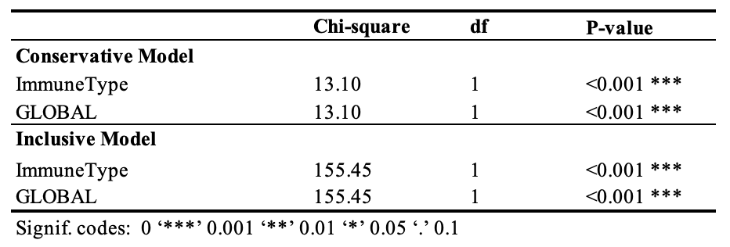

- Time-varying Cox Hazard Model
We fitted time-varying coefficient Cox models under both the inclusive and conservative outcome definitions to assess how the effects of vaccine- and infection-induced immunity on the hazard of infection evolve over time. In both models, immune status covariates were interacted with log-transformed time to allow their effects to vary continuously throughout follow-up. Under the inclusive definition, the fitted model is given by:
$$h(t)=h_{0}\left(t\right)⋅exp⁡\{3.00⋅Immune_{vac}+ 0.77⋅Immune_{infec}+0.30⋅Age_{<20}-0.13⋅Age_{20-39}-0.08⋅Age_{40-59}+0.20⋅Female-0.48⋅Immune_{vac}⋅\log\left(t\right)-0.34⋅Immune_{infec}⋅log⁡(t)\}$$
Under the conservative definition, the fitted model is shown below:
$$h(t)=h_{0}\left(t\right)⋅exp⁡\{1.37⋅Immune_{vac}+ 0.89⋅Immune_{infec}-0.20⋅Age_{<20}-0.13⋅Age_{20-39}-0.08⋅Age_{40-59}+0.25⋅Female-0.90⋅Immune_{vac}⋅\log\left(t\right)-1.04⋅Immune_{infec}⋅log⁡(t)\}$$
where $t$ represents time since the start of the first survey, with the hybrid-induced group as the reference category. The regression results are shown in Table S2.
Table S2. Time-varying Cox hazard model results

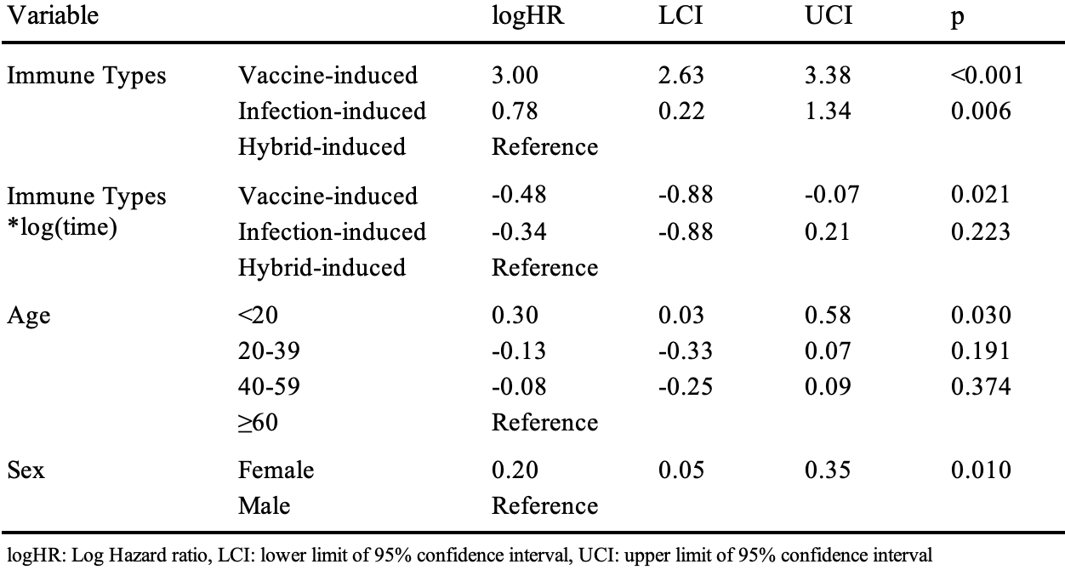
- Conservative outcome definition
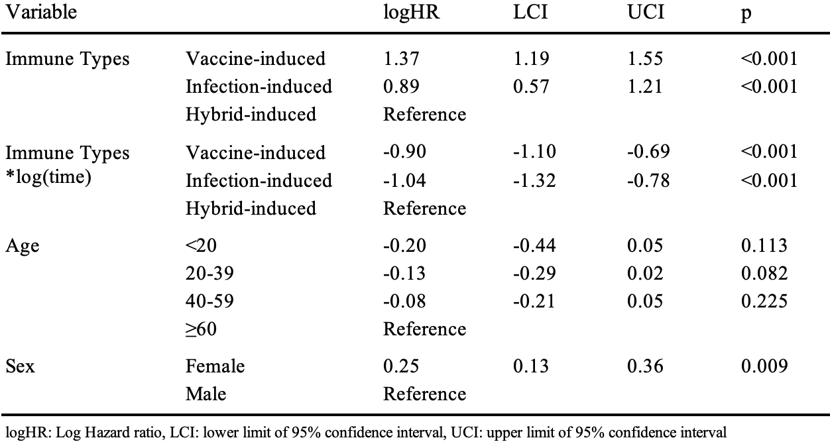
- Inclusive outcome definition
- Landmark Analysis by Monthly intervals
The tables summarize the month-by-month risk of infection over a four-month period following the first serological survey, stratified by immune type (hybrid-, vaccine-, and infection-induced). For each group and month, the number at risk, number of events, estimated hazard rate, survival probability, and the hazard ratio relative to hybrid-induced immunity are reported. Hazard ratios were calculated by comparing the event rates of vaccine- and infection-induced groups against the hybrid-induced group, with corresponding p-values derived from Fisher’s Exact Test. This descriptive analysis offers a simplified landmark-style assessment of short-term comparative risk across immune groups under two outcome definitions.

Table S3: Landmark analysis of infection risk by immunity group based on an inclusive outcome definition

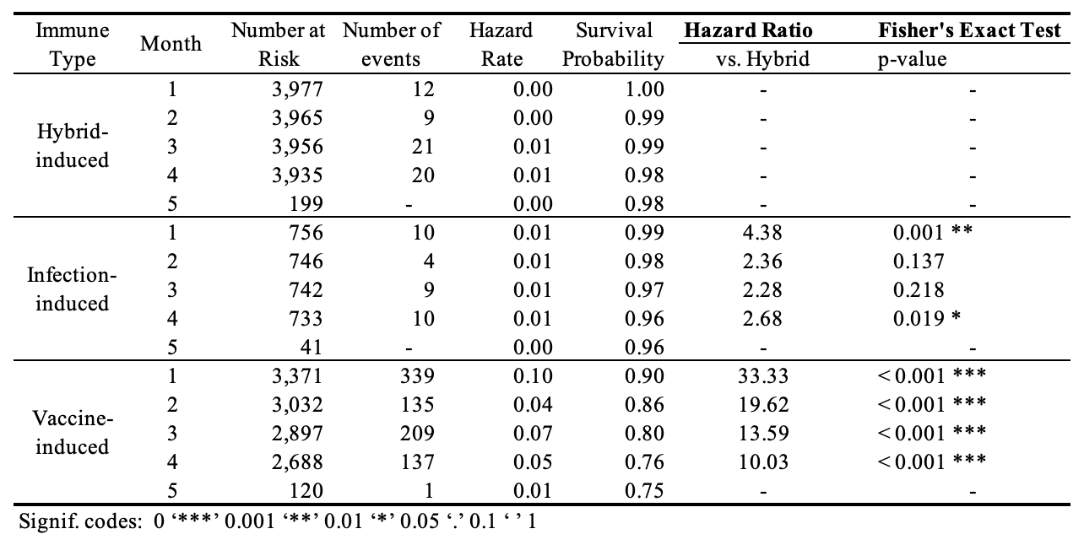

(a) Conservative outcome definition 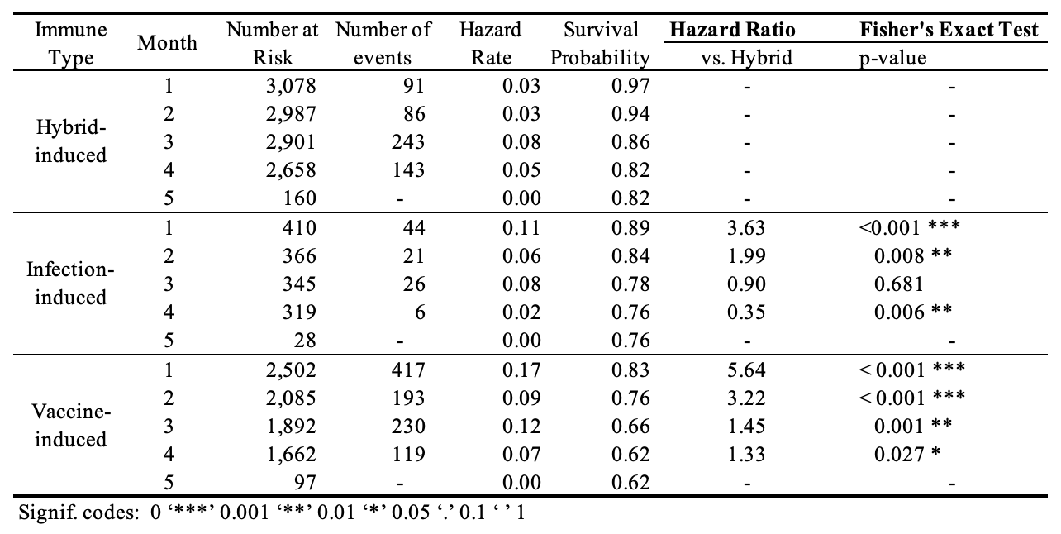
(b) Inclusive outcome definition
In the landmark analysis stratified by discrete monthly follow-up intervals, substantial differences in early infection risk were observed across immunity groups. At baseline, the vaccine-only cohort exhibited the highest hazard of infection (0.17), followed by the infection-only group (0.11), with the hybrid immunity group showing the lowest risk (0.03). Although the hybrid and infection-only groups had similar durations since their last immunological event, the infection-only group demonstrated a markedly elevated hazard in the first month (0.11 vs. 0.03). By the third month, hazard rates had increased across all groups, with the hybrid group in particular experiencing a notable rise from 0.03 to 0.08. This upward trend coincided with both natural waning of immunity and increased transmission associated with the seventh epidemic wave, which began in November 2022 and peaked in mid-December.
- Selection of Log Ratio Criteria for Inclusive Outcome Cohort

To define the inclusive outcome cohort, we applied different criteria for the hybrid and vaccine groups. For the vaccine immunity group, infections were identified based on a transformation in N status from negative to positive between the first and second survey. For the hybrid immunity group, infections were defined as an increase in N status, specifically cases where the ratio N₂/N₁>1 across the two surveys, where N₁ and N₂ are the N antibody level at the 1st and 2nd survey. Regarding the choice of the threshold for the log ratio $\log\left(N_{2}/N_{1}\right)$ for the hybrid immunity group and infection-only group, we evaluated both specificity (correct identification of non-infections) and sensitivity (correct identification of infections) using data from the KDCA cohort, with confirmed infection records serving as the reference standard. By integrating the KDCA infection status with anti-N titer levels from the Wave 1 and Wave 2, we estimated specificity and sensitivity across a range of log-ratio thresholds, as shown in Figure S1. We applied the criteria of specificity > 90% (i.e., Type I error rate α < 0.10) and sensitivity > 80% (i.e., Type II error rate β < 0.20 or power > 80%). As the threshold for defining a “significant increase” (N2/N1) rises, the sensitivity for detecting true infections increases while the risk of falsely classifying non-infected individuals as infected decreases. Log-ratio values meeting these criteria are highlighted with a grey ribbon in the figure, spanning a range from −0.32 to 0.39 for hybrid immunity group (Panel A) and from −0.38 to -0.27 for infection-only group (Panel B). Specificity and sensitivity stratified by before and after 6 months since the latest immunological event, showing the acceptable threshold ranges are −0.51 to 0.12 and −0.29 to 0.06 for hybrid groups, respectively (Data not shown). These results are generally consistent, which strongly supports the use of N2/N1 > 1 as a threshold for identifying so-called unconfirmed infections.

Figure S2: Sensitivity and specificity of N titer increase thresholds.

A. Hybrid immunity group | B. Infection-only immunity group
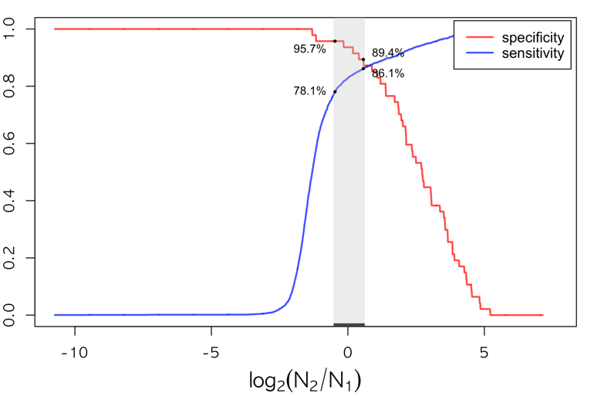 | 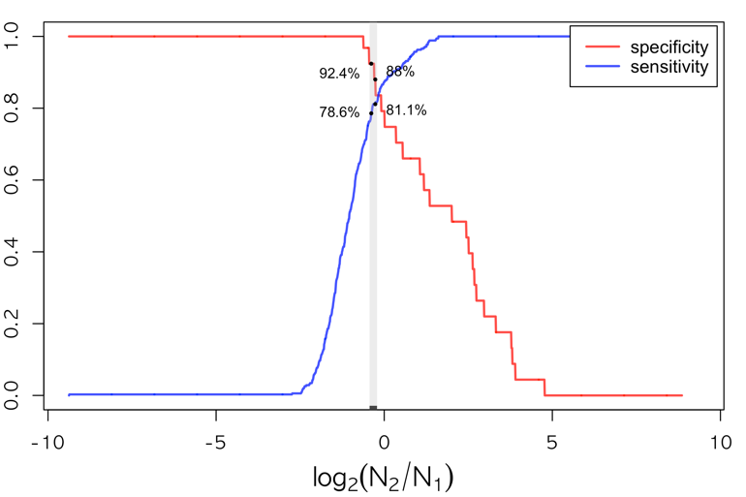
Note: The grey ribbon marks the threshold range −0.32 to 0.39 for the hybrid immunity group and −0.38 to -0.27 for the infection only group with specificity >90% and sensitivity >80%.

